NOTICE FOR ADMISSION IN CLASS PRE-NURSERY TO VIII FOR VACANT SEATS IN GOVT. SCHOOLS IN CHANDIGARH 2020-21

Education Department, Chandigarh invites online applications for admission in Pre-nursery to class VIII in Govt. Schools (Cluster Wise). Candidates can submit online application for seeking admission in nearby Govt. School. List of clusters, cluster schools and tentative vacant seats are available on the website of Education Department (www.chdeducation.gov.in) as well as Cluster school website. Candidates are advised to go through the details before submission of application form. Schedule of admission is as under:

Level | Receipt of online Application Form | Allocation of Seats | Admission in School
Pre-Primary | 31/07/2020 To  14/08/2020 | Before 21/08/2020 | 24/08/2020 To  29/08/2020
Primary |  | Before 28/08/2020 | 31/08/2020 To  05/09/2020
Upper Primary |  | Before 31/08/2020 | 07/09/2020 To  11/09/2020

Online registration form for admission from pre-nursery to class 8th will be available from 31st July 2020 on the websites of Education Department as well as Cluster schools.
On receipt of online applications, cluster head will scrutinize the applications. If the numbers of applications received are more than the seats available in particular school/class then the draw of lots will be conducted by the school concerned. Final list of students will be uploaded on cluster website and parents will be informed accordingly.
Note 1:- This application form is to be filled by only those candidates who are presently not studying in any Govt. School of Chandigarh. Request for change of school of existing students (those who are presently studying in Govt. Schools) will not been entertained at this stage.
Note 2:- As per RTE norms, admission in Govt. Schools is done as per neighborhood concept i.e. school nearest to residence. Details of the neighbourhood area (Sector/Villages near that particular school) is also uploaded on website. At the first instance admission will be given to students from the Zone 1 of the particular school, if seats are vacant then students from Zone 2 of that school will be considered, again the seats are vacant then students from Zone 3 will be considered.

In case of any enquiry / assistance parents are advised to contact on telephone to the District Education Office (0172-5021695) from 10:00am to 04:00pm
Or
Nearby Govt. school (phone number of Govt. schools are available on website) from 10:00am to 01:00pm on working day.
In case of further assistance / clarification is required , parents may visit nearby govt. school after fixing prior appointment keeping social distancing in view.

LIST OF CLUSTERS, WEBSITE, HELP LINE NUMBERS OF CLUSTER SCHOOLS:

LIST OF VACANT SEATS
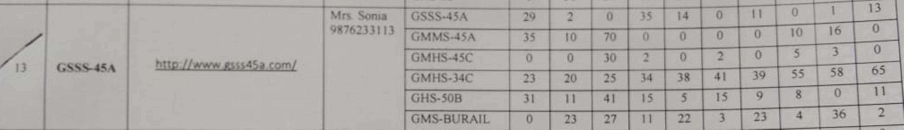

- Admission process will start from 31st july 2020.

- Online registration form for admission from pre- nursery to class 8th will be available from 31st July 2020 on the websites of Education Department as well as Cluster schools.

- Parents can fill form online.(from mobile also)

- Parents can fill form from the below given links.
http://www.chdeducation.gov.in (Education Department)
http://www.gsss45a.com (Cluster school)

